Go To: SD #72 website: www.sd72.bc.ca → District Library Learning Commons page
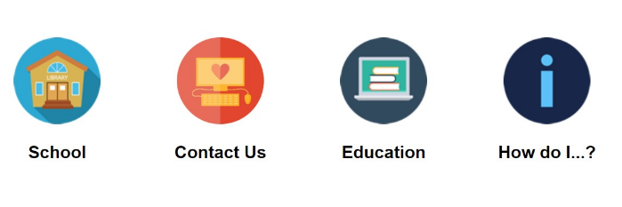
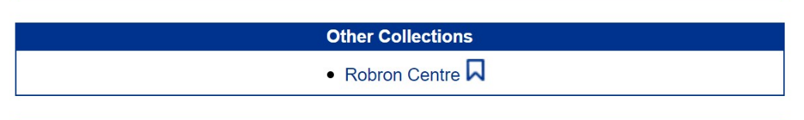
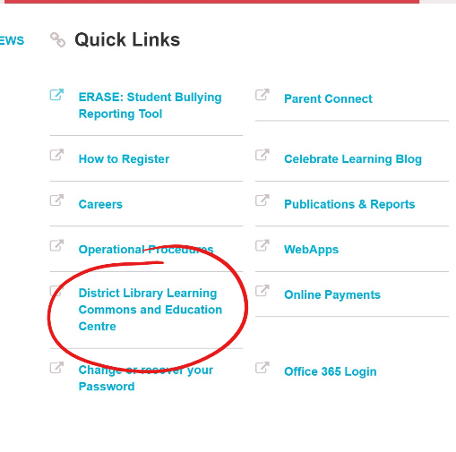
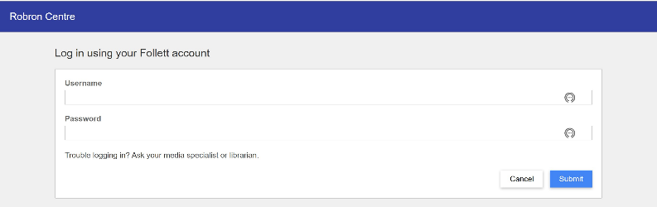
Log into Robron with your username and password:
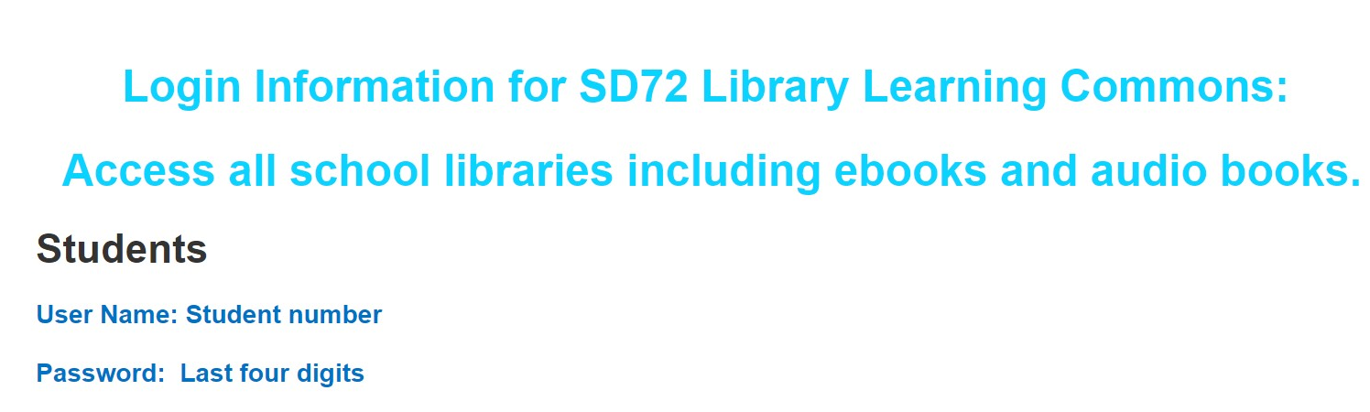

Choose a book and select BORROW Choose GO TO CHECKOUTS
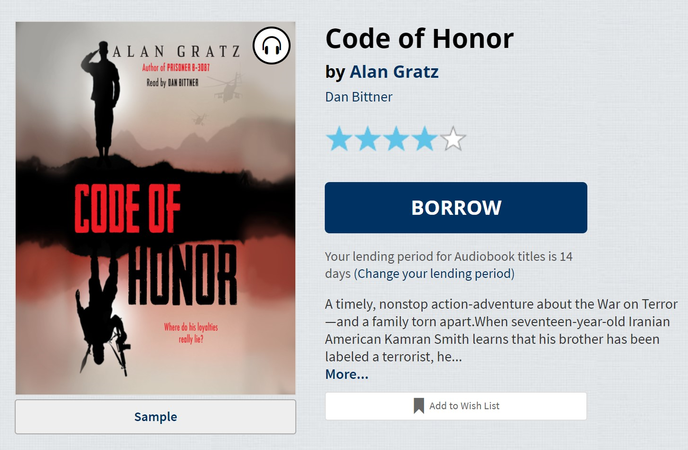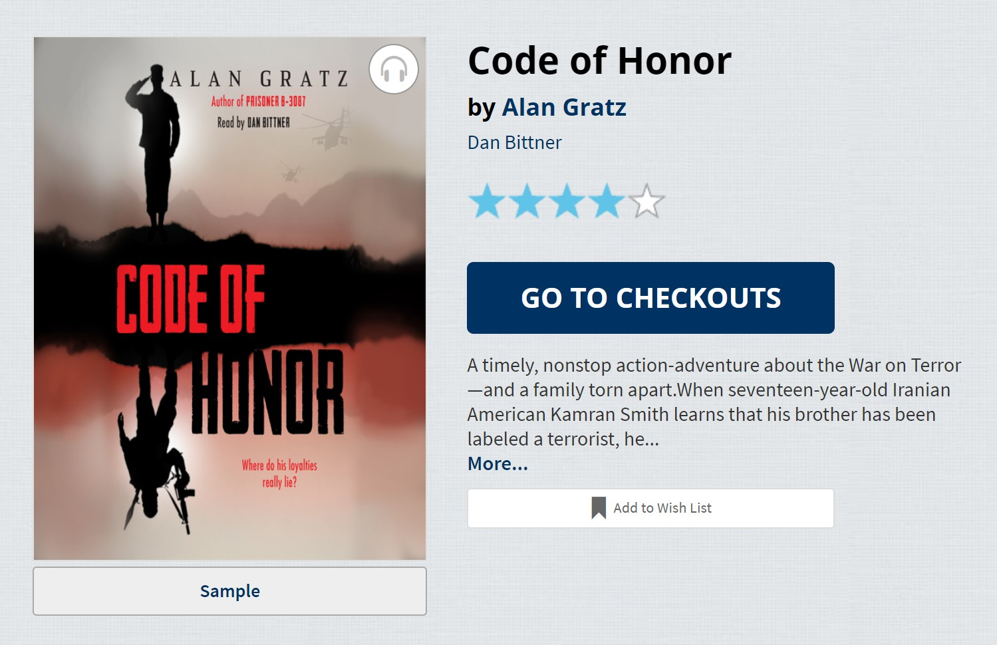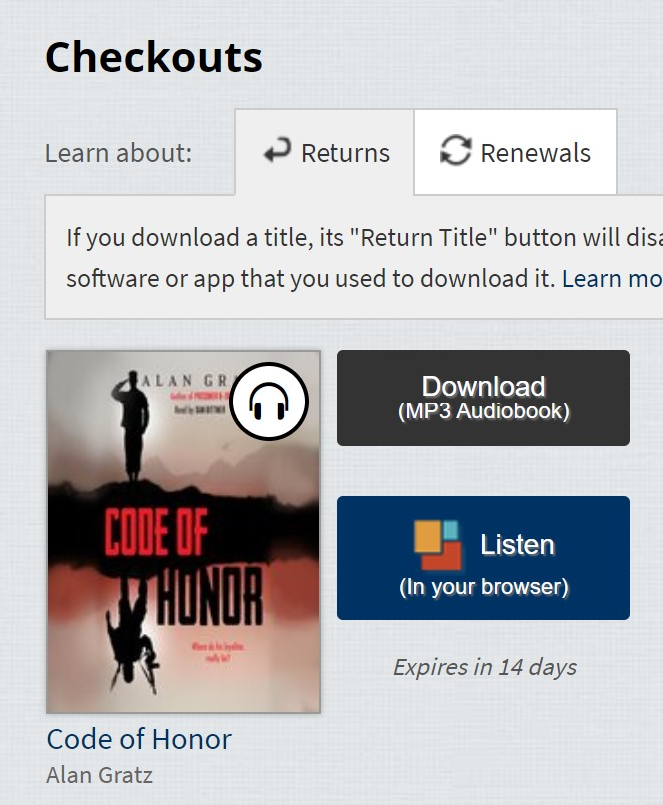
Choose Listen in Browser to listen on your phone right away. If you choose Download, it will take you through downloading the Overdrive App.
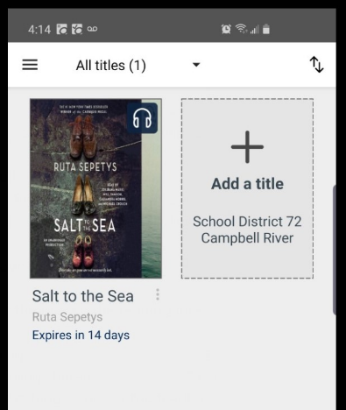
In the Overdrive App choose a book by choosing the +

You will proceed to a CHECKOUT screen. You may need to log back in using the same log in information from above.

